**OFFICIAL COORDINATION REQUEST FOR**

**NON-ROUTINE OPERATIONS AND MAINTENANCE**

**COORDINATION TITLE-** 16 LGS 16 Discharge Pipe Plug & Unit 1 Valve Rotation

**COORDINATION DATES-** September 23, 2016; May 25, 2018; January 31, 2019

**PROJECT-** Little Goose Lock and Dam

**RESPONSE DATE-** February 13, 2019

**Description of the problem:** The replacement of the powerhouse unwatering pumps, discharge piping, and the oil/water separator skimmer system are scheduled from September 4, 2019 to January 15, 2020. The drainage and unwatering pumps work together to keep the dam from flooding out due to leakage and to dewater the various assets of the powerhouse such as the main units, fish pumps and fish channel. The replacement will require a mechanical pipe plug to be installed in the embedded unwatering pump discharge pipe located in the tailrace approximately 25 feet upstream of the south adult fishway entrance at a depth of 20 feet while the unwatering discharge isolation valve is replaced, as seen in the figure one below.

Per dive safety regulations water velocities must not exceed 1 knot and there can be no entrapment area such as a pump intake within 100 feet of the diver. Given the close proximity of the south adult fishway entrance, it will need to be closed during the installation and removal of the plug as well as shutting down the drainage and unwatering pumps themselves. Fish pumps 1, 2 will need to be shut down during the work as they are within 100 feet of the diver. Units 1 and 2 will need to be OOS as well which will mean that Units 3 and 4 become the priority units.

This work cannot be performed during the January/February fish ladder outage before or during the contract for the following reasons:

* Leakage flows into the drainage and unwatering sump are near peak levels during this time, which leaves an insufficient amount of time to install the plug, as both the drainage and unwatering pumps will be shut down and the powerhouse will be relying on the storage capacity of the sumps to keep from flooding. While some leakage can be diverted from the sump the inflow will still be too great.
* The current drainage pumps do not have the capacity to handle all the leakage inflow between December and April. During this time the unwatering pumps are needed to keep the power house from flooding and therefore cannot be taken off line.

The skimmer work requires that the 18” drain valve for Unit 1 Scroll Case be rotated 180 degrees to facilitate concrete removal and the new skimmer equipment. This work is scheduled to be done between late June and early July. Unit 1 will need to be taken off line for 2 days in order to complete the work. This work cannot be moved to the in water work window due to critical timing issues with the drainage and unwatering pump replacement.

**Type of outage required:** For the dive work Units 1 and 2 and Fish Pumps 1 and 2 will be offline up to 3 days during mid-October – mid-November. For the valve rotation Unit 1 is out for two days late June – early July.

**Impact on facility operation:** South adult fishway entrance will be closed for up to a maximum of 3 days for dive work. During this period, pump 3 will be operated at the top end to provide enough flow in conjunction with other inputs to keep both NPE and NSE operating within FPP criteria. If needed in order to stay within criteria, we will adjust NPE to 6’ head over weir to maintain the FPP criteria. During late June – early July Unit 1 outage, the next unit in priority (unit 2) will be operated.

**Dates of impacts/repairs:** Up to 3 consecutive days between mid-October and mid-November for the dive work and 2 consecutive days for the Unit 1 valve rotation between late June and early July.

**Length of time for repairs:** Due to the time it takes to shut down and re-start fish pumps and close/open the fish ladder entrance, fish pump 1 and 2, Unit 1 and 2 and the south fish ladder entrance would need to be closed for up to 3 days for the duration of the dive work. Actual drilling will occur for a total of 40 mins. Unit 1 would be OOS 2 days for the valve rotation in late June – early July.

**Overall impacts on fish passage:** The adult fish system will be operated in a modified configuration during the dive work due to the closure of the south shore fishway entrance. However, the impact should be minimal as the dive work will be conducted between mid-October and mid-November when 98.5% of chinook, 68.2% of coho and 84.9% of steelhead have already passed the dam based on 2018 counts. During any 3 day interval within this mid-October thru mid-November timeframe we expect 1.5% of steelhead, 3.2% of coho, and 0.2% chinook to move thru the ladder based on 2018 counts. We will have two other entrances operating normally within FPP criteria, therefore providing good attraction conditions for passage into and thru the ladder. The following calculations (by a hydraulic engineer) were done to further reinforce that we will be able to run both remaining entrances within criteria with only fish pump 3 operating at maximum. NSE should be between 1' and 1.25' of head with a weir depth of 6.0' below tailwater. NPE should be between 1.5' and 1.7' of head with a weir depth of 8.0' below tailwater. If needed in order to stay within criteria, we will adjust NPE to 6’ head over weir to maintain the FPP criteria. Channel velocity should be about 1.6 fps heading towards NSE and 3.6 fps along the powerhouse. There are four anchors that need to be drilled, and the drilling for each anchor is expected to take 10 minutes, for a total of 40 mins of drilling activity. The drilling will occur on the other side of an 8 ft thick concrete wall.

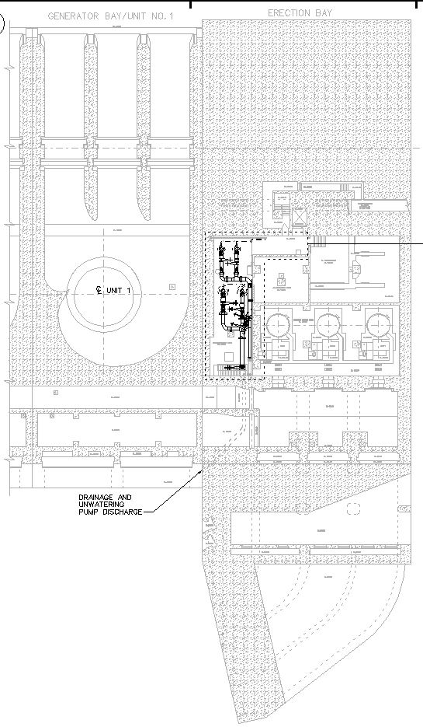

Fish Pump 2 Intake

Fish Pump 1 Intake

Isolation Valve to be Replaced

Unwatering Pumps

Drainage Pumps

South Fishway Entrance

Dive location

Drainage discharge located 2 feet above unwatering discharge

Figure 1 Plan View EL 498

1. **Analysis of potential impacts to fish. Include:**
   1. 10-year average passage of adults and juveniles of each affected listed species during dates of impact.

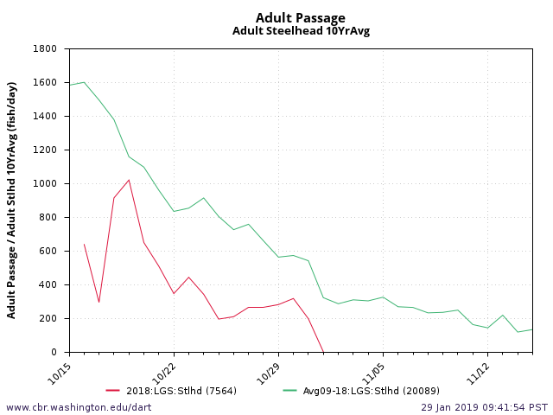

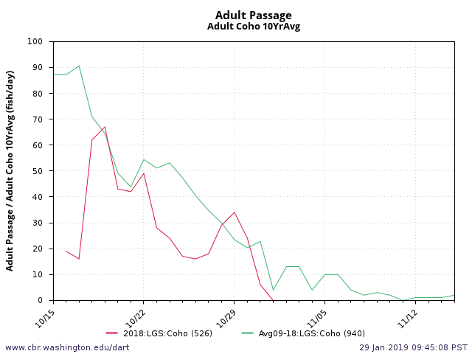 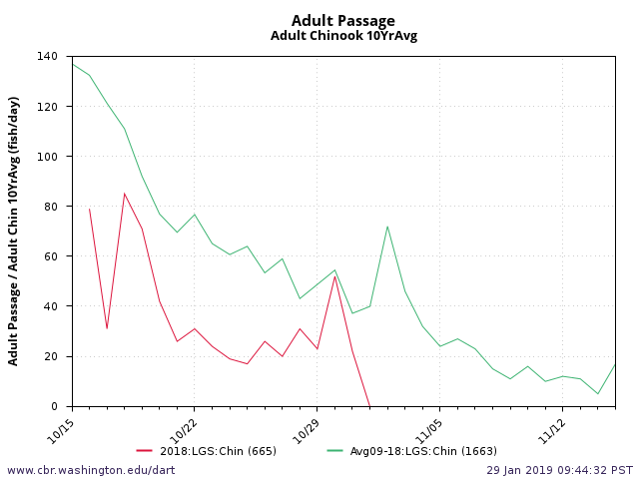

specific to the late June-early July unit 1 two day outage see graphs below:

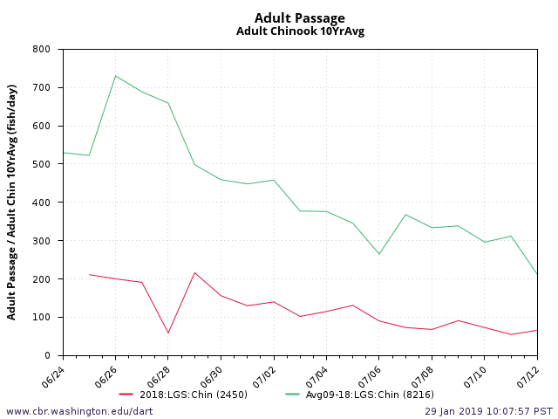

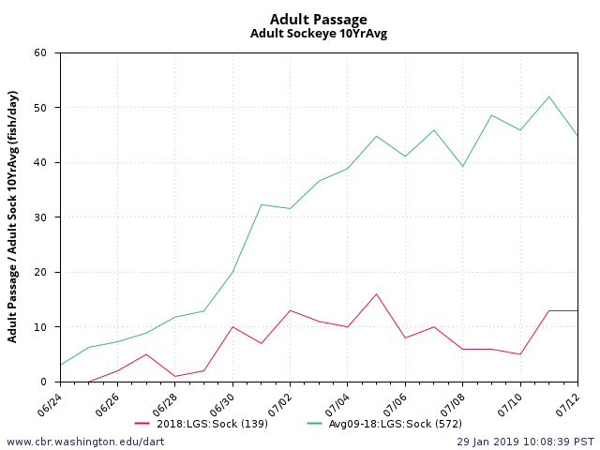

* 1. Statement about the current year’s run.
     1. Pre-season – NOAA adult returns forecast: 2019 returns of steelhead are expected to be similar to 2018 due to continued poor ocean conditions, however no forecast has yet been released. This would mean run size is anticipated to continue below the 10 year average. Specific to late June-early July unit 1 outage, both the spring CH and sockeye forecasts predict 2019 returns to be slightly below 2018.
  2. Type of impact : This is expected to be low to no impact on adult passage since units 1, 2 will be offline and adult entrances at NSE, NPE will be operated within FPP criteria and provide attractive entrance conditions. There will be 10 mins of exposure to drilling on the other side of a concrete wall four times during the outage 15 Oct -15 Nov. For the Unit 1 outage in late June- early July, we will be operating with summer spill program and the short outage of unit 1 is not expected to cause delay of passing fish due to a tailrace eddy.
  3. Final judgement on scale of expected impacts (negligible, minor, significant) on:
     1. Minor to no impact to any passing downstream migrants as any operating units will be screened.
     2. Low to no delay to upstream migrants as NSE, NPE will be operating within FPP criteria and units 3, 4 are as close to NPE as to SSE.

**Comments from agencies**

**From:** Bill Hevlin - NOAA Federal

**To:** Setter, Ann L NWW

**Cc:** Bill Hevlin - NOAA Federal; Trevor Conder - NOAA Federal

**Subject:** [EXTERNAL] Re: Coordination: 16 LGS 15 Discharge Pipe plug

**Date:** Friday, September 23, 2016 9:50:22 AM

Hi Ann,

This relatively short delay in the tailrace during the late afternoon should not be a problem for the small number of adult fall chinook migrants passing Little Goose during two days in November. Apparently the divers can operate safely in the tailrace at night, this just seemed a little risky to me. We can talk more about this at the FPOM meeting in October, but for now NOAA does not have a problem with this planned action.

Thanks for coordinating with us

Bill Hevlin

NOAA Fisheries

May 24, 2018 Issue of moving this outage one year forward was discussed at May FPOM mtg, agency representatives approved this outage date change.

**Final results**

**After Action Update**

Please email or call with questions or concerns.

Thank you,